**NAME : Muhammad Huzaifa**

**STUDENT ID : BIT-24S-17**

**DEPARTMENT : INFORMATION TECHNOLOGY**

**SUBJECT : ARTIFICIAL INTELLIGENCE**

**LAB : 08**

**TASK: 01**

**Make a calculator using the function the code should use only 2 operands(+ and -) for division and multiplication as well.**

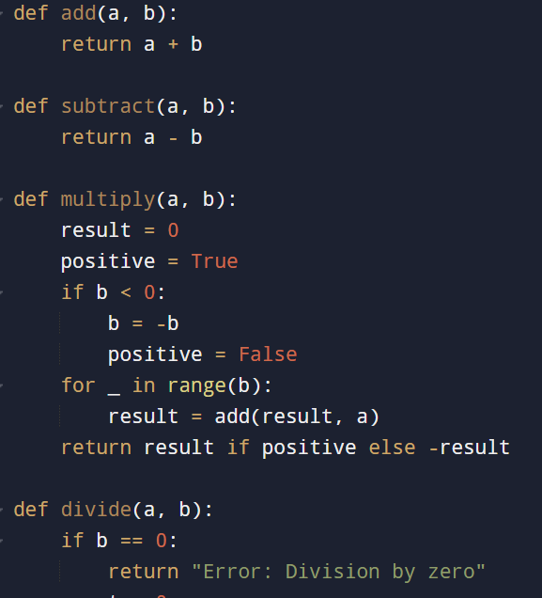

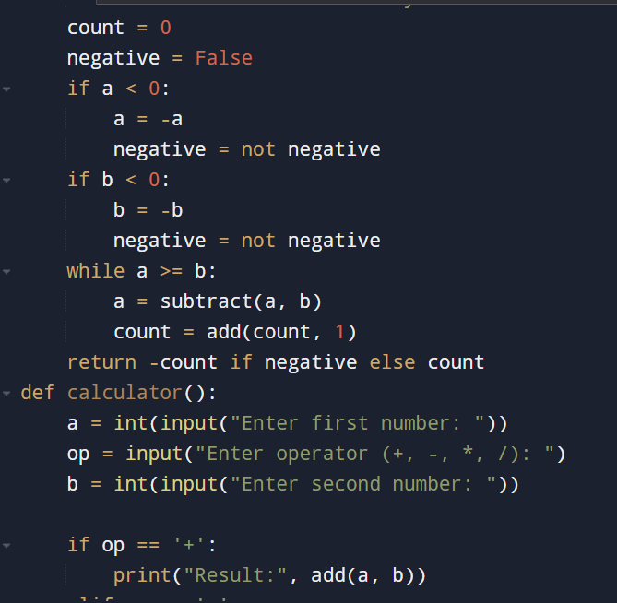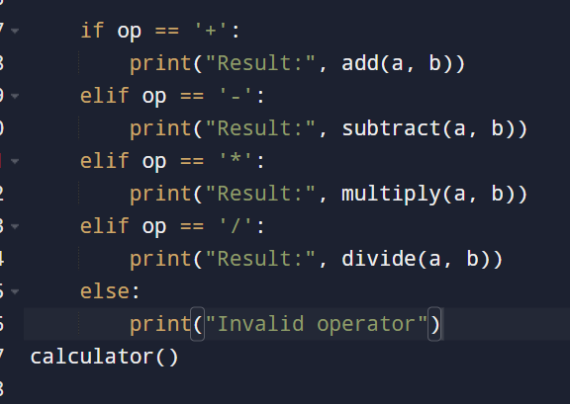

**OUTPUT:**

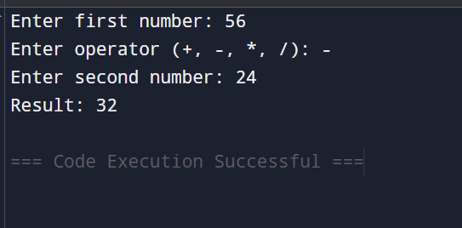

**TASK:02**

**Write a functions that ask the user the shape and make the star shaped. (Like it asks the shape (triangle or Rectangle) and make that shape.**

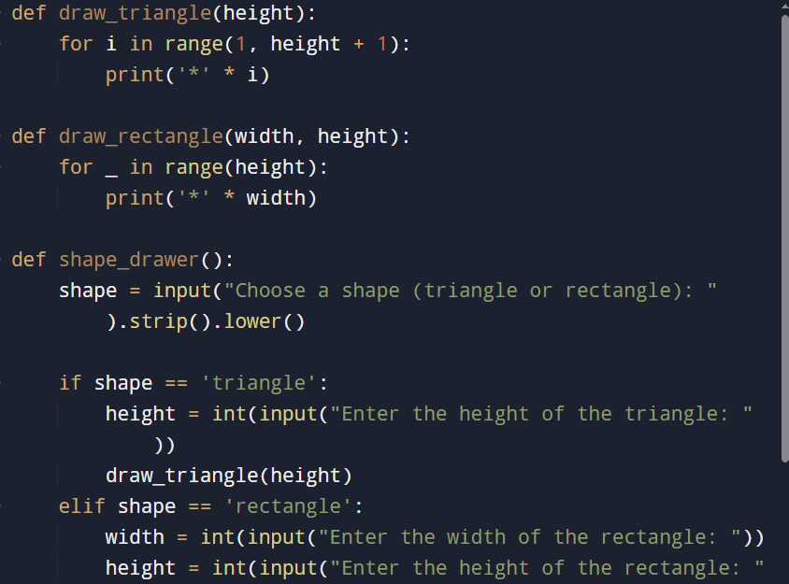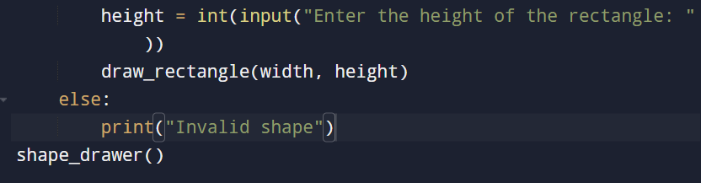

**OUTPUT:**

